*Project Report on*

**Effect of SRM (Student Relationship Management) on Student Satisfaction at TIET: A Survey based analysis**

Submitted By:

Tarandeep Singh (102115038)

Under the Guidance of

Ms. Rishita Goyal



School of Humanities and Social Sciences

Thapar Institute of Engineering and Technology

(April 30,2024)

### TABLE OF CONTENTS

**COPYRIGHT NOTICE**………………………………………………………………………. 3

**LETTER OF TRANSMITTAL**………………………………………………………………. 4

**CERTIFICATE**…………………………………………………………………………………5

**ACKNOWLEDGEMENT**……………………………………………………………………...6

**EXECUTIVE SUMMARY**……………………………………………………………………..7

**INTRODUCTION**……………………………………………………………………………....8

**LITERATURE REVIEW**…………………………………………………………....…………9

### SCOPE AND SIGNIFICANCE OF THE STUDY……………………………………………10

**OBJECTIVES OF THE STUDY**………………………………………………………………10

**CONCEPTUAL FRAMEWORK** …………………………………………….….……………11

**RESEARCH METHODOLOGY**……………………………………………………………...11

**DATA SOURCES**……………………………………………………………………………… 11

**RESEARCH TOOL**……………………………………………………………………....…… 12

**SAMPLING**……………………………………………………………………………………. 12

### DATA ANALYSIS AND INTERPRETATION………………………………………………. 12

**CONCLUSION**………………………………………………………………………………… 17

**LIMITATIONS OF THE STUDY**…………………………………………………………….. 18

**APPENDIX**……………………………………………………………………………………... 19

**REFERENCES**…………………………………………………………………………………. 21

# COPYRIGHT NOTICE

©Copyright 2024 by Thapar Institute of Engineering & Technology. All rights reserved. This material may not be duplicated for any profit-driven approach.

The reports contained in these Internet-accessible directories are included by the contributing authors as a mechanism to ensure the timely dissemination of scholarly and technical information on a non-commercial basis. Copyright and all rights therein are maintained by the authors, despite their having offered this information electronically. Everyone copying this information must adhere to the terms and constraints invoked by each author's copyright.

Reports may not be copied for commercial redistribution, republication, or dissemination without the explicit permission of the School of Humanities & Social Sciences at Thapar Institute of Engineering & Technology, Patiala and the authors.

# LETTER OF TRANSMITTAL

Date: Apil 30th, 2024

Respected Ma’am,

This is to inform you that I am submitting my report on: Effect of SRM (Student Relationship Management) on Student Satisfaction at TIET: A Survey based analysis. This is based on real time investigation through a structured questionnaire implemented in TIET campus. The students belonging to age groups 17-24 across computer and non-computer branches were surveyed.

This research was undertaken as partial fulfilment of Humanities for engineers (UHU004) course requirement.

This project proports to understand various factors that makeup SRM and influence student satisfaction in the college. The author plans to develop this report into a full-fledged research work and intends to get it presented while sending it to renowned journals for publication as well.

Yours Sincerely,

Tarandeep Singh (102115038)

# CERTIFICATE

This is to certify that the project report on **‘’** **Effect of SRM (Student Relationship Management) on Student Satisfaction at TIET: A Survey based analysis** is a bonafide project work done originally by **Tarandeep Singh (102115038)** in fulfilment of the project work given by the School of Humanities and Social Sciences, Thapar Institute of Engineering and Technology during the year 2024.

### Ms Rishita Goyal

Date: April 30, 2024

Place: Patiala

# ACKNOWLEDGEMENT

At the outset, I would like to articulate this project on the topic - Effect of SRM (Student Relationship Management) on Student Satisfaction at TIET: A Survey Based analysis as a small journey that was a remarkable learning experience.

First of all, I would like to sincerely thank my professors who have given me this opportunity without which it was not possible for me to embark on the journey of learning and experience. My heartfelt thanks go to mam Rishita Goyal, who has never stopped believing in me, motivated me and never accepted less than my full potential.

At last, my peers, seniors and juniors deserve an honourable mention for cooperating with me for filling my questionnaire and giving me their time and feedback.

# EXECUTIVE SUMMARY

The project is aimed at finding out the association between the student relationship management (SRM) practices followed at Tiet and the satisfaction of students. To set the backdrop for my survey, a thorough analysis of previous studies was carried out and a probable relationship between SRM postulates and student satisfaction was hypothesised. This relationship was tested via a questionnaire specifically prepared for this purpose. The secondary data from literature coupled with discussion with professors and students at TIET helped in designing questions to be asked to explore the said relationship. The questionnaire was made on google forms and distributed through a QR code. This questionnaire was filled by one-on-one meeting with the students and requesting them to take time and fill the forms for our survey in real time. Though a pretest of the questionnaire was also conducted on around 5-7 students beforehand, this face-to-face filling of questionnaire further helped in ensuring complete understandability of the respondents.

The responses received in the form of google spreadsheet were transferred to ms excel and then coded. This coded data was then transferred to IBM SPSS to generate various inferences. First of all the reliability of the questionnaire was checked by applying Cronbach’s alpha. The statistical tools used were percentages, mean, bar charts, graphs correlation, regression etc.

On a concluding note, I was able to identify the relative importance of various factors (that constituted SRM) which have maximum influence on the satisfaction of students at TIET.

### Student Satisfaction among college students- An Introduction

Satisfaction is the feeling of contentment, fulfilment, and completeness. It results from various aspects both internal and external. It often results in increased wellbeing. It can be towards a particular group or object you own or are a part of.

College is one of the places where each student has certain expectations and satisfaction related to this is based on fulfilment of these hopes.

According to statista.com(2023), the overall level of satisfaction of students with higher education in India had decreased significantly in 2020. About 66 percent of the students were satisfied with the course earlier in the country and this had decreased to 53%.

The satisfaction of a college student with their university depends on many factors both academic and non-academic. Student’s satisfaction depends upon the accomplishment of their aspirations. What they aspire for is a good environment, good studies and ultimately good salaries and opportunities.

At the very core, the student is also a kind of customer for the educational institution and thus their gratification is vital for the institutions they are affiliated with.

The students want a decent environment on campus for studying, eating, resting with security and safety. The students need basic state of art facilities like libraries, smartboards, labs, etc. They also require good food, internship opportunities and updated curriculum etc.

By thoroughly assessing these elements, educational institutions can understand student contentment better. Utilizing tools like surveys, group discussions, and final interviews, colleges can pinpoint their strong points and areas needing improvement. This information can guide them in making specific enhancements, resulting in a more rewarding and fulfilling learning journey for students.

Increased satisfaction and involvement will allow the students to interact better, perform better and finally get paid better. This means that by ensuring student satisfaction, they potentially create the last push that can let students become better. This will increase the repute of the college, causing it to attract more elite people and this will intern help them secure better ranks.

# LITERATURE REVIEW

|  |  |  |  |  |
| --- | --- | --- | --- | --- |
| Sno. | Author(s) | Title | Methodology | Findings |
| 1 | O’Brien et al (2007) | A study into the factors influencing the choice-making process of Indian students when selecting an international university for graduate studies using Grounded Theory | The attempt was to uncover the choice factors affecting undergraduates while they go for international studies. Grounded theory approach formed the very basis of this work. Qualitative /quantitative survey and focus group responses were suitably coded to draw inferences. | The important variables uncovered for the purpose were the desire for self-improvement, the desire to increase personal opportunities in the job market, the desire to keep with family tradition, and, culture and normative referents. |
| 2 | Ming  (2010) | Institutional Factors Influencing Students’ College Choice Decision in Malaysia: A Conceptual Framework | This paper aimed at developing a conceptual framework to explore the institution factors that influence students’ college choice decision. | Yielded a conceptual framework wherein students choice of college was taken as a dependent variable and college characteristics along with the effort of the college to market itself to students made up independent factors |
| 3 | Bowden  (2011) | Engaging the Student as a Customer: A Relationship Marketing Approach | The research used SEM approach, based on a survey of 474 students. | Psychological factors and attachment to the brand of the university were the most important factors for determining the student loyalty. It also indicated that student satisfaction and trust were not significant. |
| 4 | Oluseye et al (2014) | Customer Relationship Management Approach and Student satisfaction in Higher Education Marketing | A survey was conducted on two private universities in Nigeria. The relationship between student lifecycle management and their willingness to recommend was explored. A multiple regression analysis was employed in the hypothesis testing | Research indicates that when universities effectively manage the student lifecycle, students are more likely to recommend the institution to others. Strong parent relationship management by the university positively impacts students' willingness to endorse their university. |
| 5 | Gray & DiLoreto (2016) | The Effects of Student Engagement, Student Satisfaction, and Perceived Learning in Online Learning Environments | Survey along with mediation analysis were utilised to explore the relationship between student learning and satisfaction on 1 hand and course structure, presence of teacher and interaction of students with one another. | The researchers further hypothesized that student engagement mediates the relationship of learner interaction and instructor presence on both perceived student learning and student satisfaction. |
| 6 | Bueno (2023) | Enhancing Graduate School Experience: A Comprehensive Evaluation of Student Satisfaction with Services and Facilities | Surveys and interviews of graduates across various disciplines in Philippines were used to investigate the effect of college facilities on their success. Thematic analysis of qualitative data of 20 respondents was done. | It was seen that the student academic performance and success of the school were dependent upon the facilities provided by the graduate school. |
| 7 | Furqon et al (2023) | The Impact of Learning Management System (LMS) Usage on Students | The methodology followed in the paper was review of existing literature published in 2015–2021-year range. | The results of the study indicated the positive impact of LMS on the academic performance, positive perceptions and satisfaction of the students. |

# SCOPE AND SIGNIFICANCE OF STUDY

As a student of TIET, I felt a sense of responsibility while carrying on this research. Though the project was started with an aim to fulfil the requirement of a course, I felt excited that my efforts could actually mean something valuable for my college. The topic of Student satisfaction has been far researched but applying it to understand the student satisfaction for TIET made it interesting for me and filled me with a sense of belonging for my college. The implementation of the concepts of CRM (Customer Relationship Management) to derive SRM postulates and then exploring the relationship with student satisfaction at my college made this study theoretically and practically viable.

# OBJECTIVES OF THE STUDY

* To find out the relationship between independent variables and dependent variables and to decipher the extent to which the independent variables considered in the model account for the variation in the dependent variable.
* To understand which of the independent variables have an influence on the dependent variable.

# CONCEPTUAL FRAMEWORK

Source- Hypothesised By Tarandeep Singh

# RESEARCH METHODOLOGY

The survey questionnaire was filled by around 130 students. After filtering the fully completed questionnaires, 118 forms were selected for data interpretation and implementation of statistical tools. The questionnaire consisted of 3 Questions namely name, age and email related to demography. It had two psychographic questions related to course and year of the student. There were 6 questions related to infrastructure, 4 linked to technology, 4 associated to curriculum and 5 connected to placement. Further 4 questions were also asked to measure the dependent variable.

First of all, frequencies for the age variable were generated followed by the reliability analysis. Then correlation and Regression was carried out via SPSS.

# DATA SOURCES

## • Primary Data

A questionnaire was filled out by the people. The data collected and the interpretations of the same are presented ahead in this report.

## • Secondary Data

Research papers, journals, and magazines were studied. Information from Podcasts was also taken into consideration.

# RESEARCH TOOL

The questionnaire, created through google forms was used as survey instrument.

# SAMPLING

The target sample chosen was restricted to TIET in order to reach at the above mentioned objectives.

*Sample Unit* - The students of the Thapar Institute of Engineering and Technology are the sample unit in the survey.

130 students was the sample size for my survey.

# DATA ANALYSIS AND INTERPRETATION

|  |  |  |  |  |  |
| --- | --- | --- | --- | --- | --- |
| **Table1: Age** | | | | | |
|  | | Frequency | Percent | Valid Percent | Cumulative Percent |
| Valid | below 20 | 83 | 70.3 | 70.3 | 70.3 |
| 21 and above | 35 | 29.7 | 29.7 | 100.0 |
| Total | 118 | 100.0 | 100.0 |  |

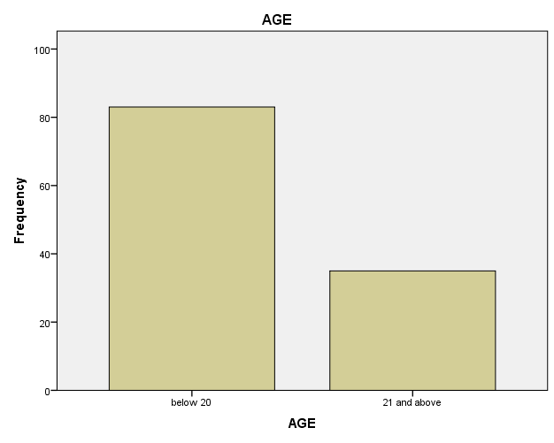

Fig1: Age

### Interpretation

70% respondents belong to 20 or below category with around 30% being 21 and above

**Reliability**

|  |  |
| --- | --- |
| **Table2: Reliability Statistics** | |
| Cronbach's Alpha | N of Items |
| .936 | 19 |

### Interpretation

As the Cronbach’s Alpha’s value is above .90 which shows that the scales used to measure the independent variables were reliable.

**Infrastructure**

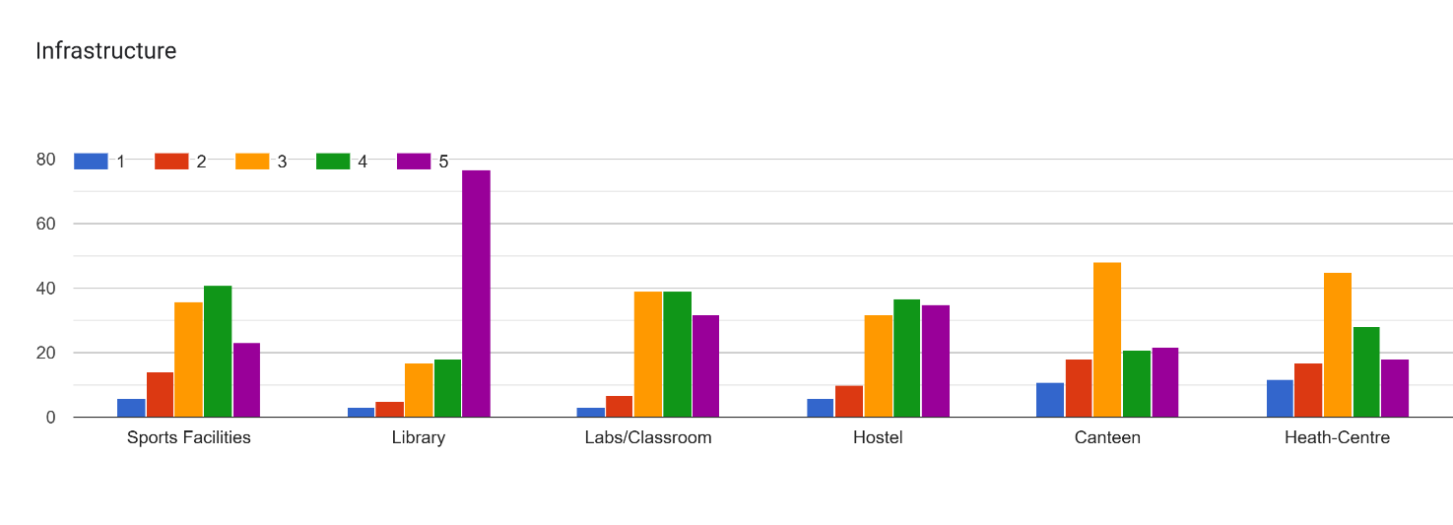

Fig2: Infrastructure

**Interpretation:-**

Sports Facilities: Most of the people rated it as Good.

Library: Most people rated it as 5/5.

Labs and Classrooms: The respondents were divided on their opinion and rated these as either 3 or 4.

Hostels: Very few people rated it as 1 or 2.

Canteen: Most of the people rated it as 3.

Health Centre: Most of the people rated it as 3.

Technology

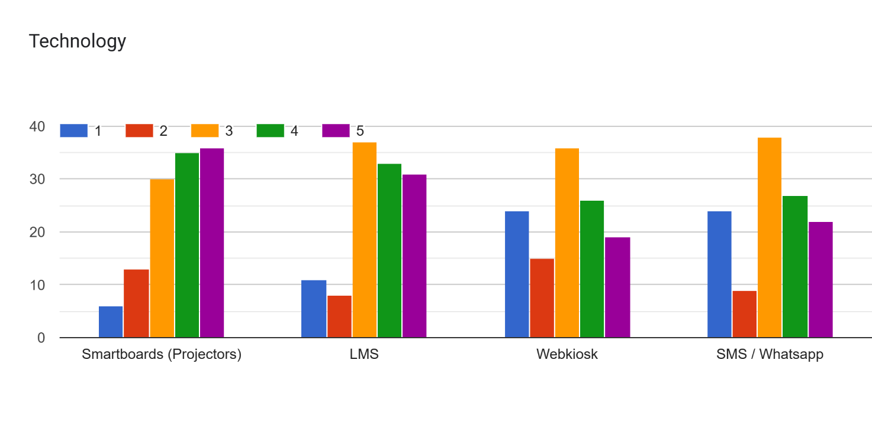

Fig3: Technology

**Interpretation:-**

Smartboards: Rated as 3/4/5 by majority and results were similar for LMS

Web kiosk: Maximum students rated it as 3/5 and similar results for SMS /Whatsapp

Curriculum

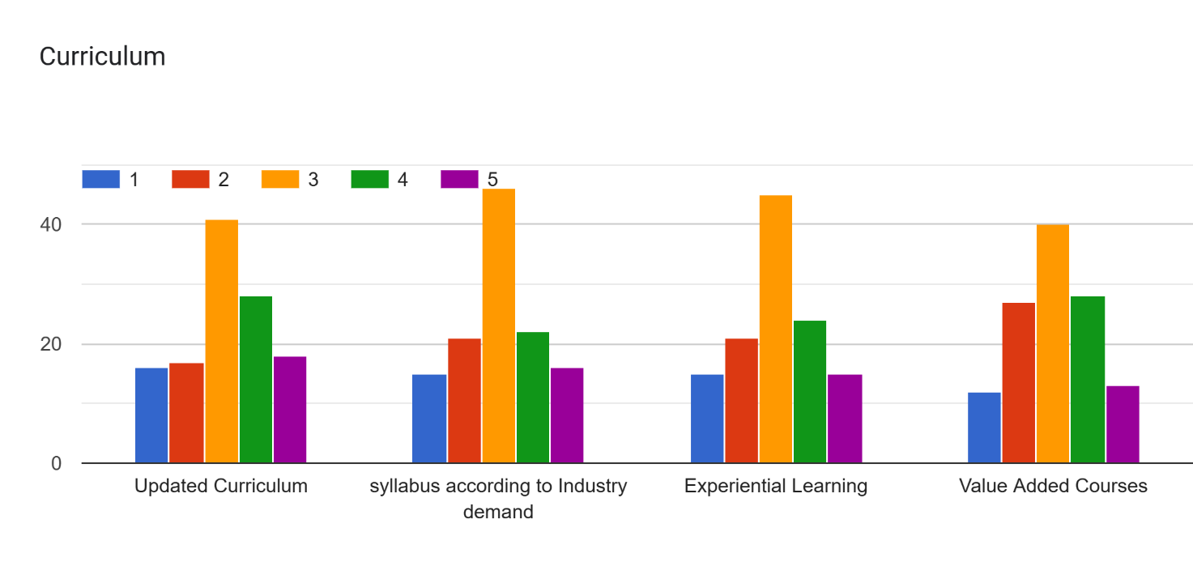

Fig4: curriculum

**Interpretation:-**

Rated as 3/5 on all parameter by most students.

**Placement**

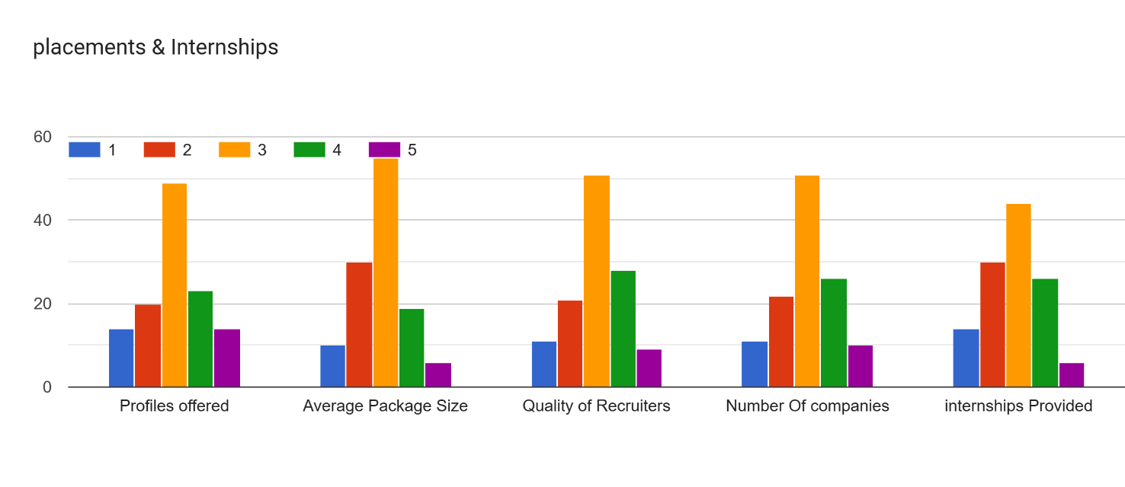

Fig5: Placement

**Interpretation:-**

Again rated as 3/5 on all parameter by most students.

**Student Satisfaction**

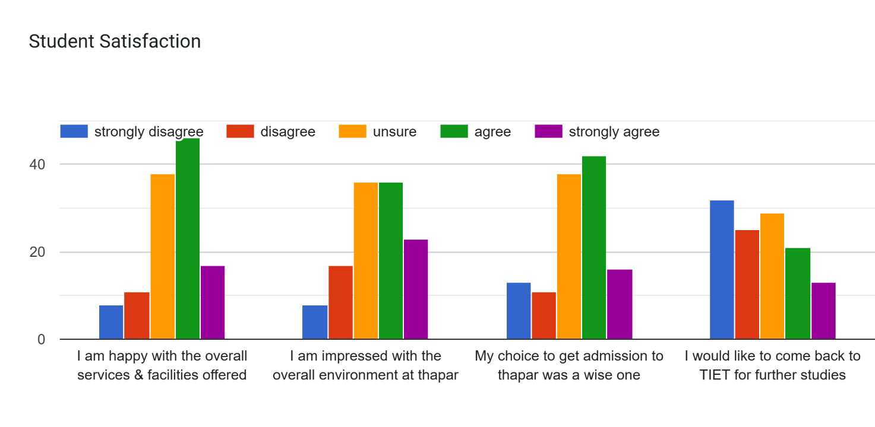

Fig6: Student Satisfaction

**Interpretation:-**

Service & facilities: Most students agreed when asked about their satisfaction on the said parameter

Overall environment: Most students agreed or were unsure about their satisfaction with this Parameter

Choice to get admitted: Agree and strongly agree collectively outnumbered other categories.

Return to Tiet: Most students disagreed strongly or simply about returning to TIET for further studies.

Table 3: **Correlations**

|  |  |  |  |  |  |
| --- | --- | --- | --- | --- | --- |
| **Correlations** | | | | | |
|  | | infrastructure | Technology | Curriculum | Placement |
| infrastructure | Pearson Correlation | 1 | .572** | .589** | .600** |
| Sig. (2-tailed) |  | .000 | .000 | .000 |
| N | 118 | 118 | 118 | 118 |
| Technology | Pearson Correlation | .572** | 1 | .646** | .535** |
| Sig. (2-tailed) | .000 |  | .000 | .000 |
| N | 118 | 118 | 118 | 118 |
| Curriculum | Pearson Correlation | .589** | .646** | 1 | .708** |
| Sig. (2-tailed) | .000 | .000 |  | .000 |
| N | 118 | 118 | 118 | 118 |
| Placement | Pearson Correlation | .600** | .535** | .708** | 1 |
| Sig. (2-tailed) | .000 | .000 | .000 |  |
| N | 118 | 118 | 118 | 118 |
| **. Correlation is significant at the 0.01 level (2-tailed). | | | | | |

**Interpretation:**

The correlation table suggest a positive correlation between various independent variables. Further, It can also be seen that these correlations are significant at 0.01 level.

**Regression**

Table4: Model Summary

|  |  |  |  |  |
| --- | --- | --- | --- | --- |
| **Model Summary** | | | | |
| Model | R | R Square | Adjusted R Square | Std. Error of the Estimate |
| 1 | .720a | .518 | .501 | .69958 |
| a. Predictors: (Constant), Placement, Technology, infrastructure, Curriculum | | | | |

**Interpretation:**

The above table suggests that around 50% of the variation in the dependent variable- student satisfaction is caused by the predictors chosen. Moreover, the ANOVA table given below clearly depicts that the model is significant.

Table5: ANOVA

|  |  |  |  |  |  |  |
| --- | --- | --- | --- | --- | --- | --- |
| **ANOVAa** | | | | | | |
| Model | | Sum of Squares | df | Mean Square | F | Sig. |
| 1 | Regression | 59.478 | 4 | 14.870 | 30.382 | .000b |
| Residual | 55.304 | 113 | .489 |  |  |
| Total | 114.782 | 117 |  |  |  |
| a. Dependent Variable: Student_Satisfaction | | | | | | |
| b. Predictors: (Constant), Placement, Technology, infrastructure, Curriculum | | | | | | |

Table6: Coefficients

|  |  |  |  |  |  |  |
| --- | --- | --- | --- | --- | --- | --- |
| **Coefficientsa** | | | | | | |
| Model | | Unstandardized Coefficients | | Standardized Coefficients | t | Sig. |
| B | Std. Error | Beta |
| 1 | (Constant) | .186 | .316 |  | .590 | .556 |
| Infrastructure | .281 | .114 | .220 | 2.471 | .015 |
| Technology | .200 | .088 | .204 | 2.264 | .025 |
| Curriculum | .125 | .098 | .133 | 1.275 | .205 |
| Placement | .318 | .104 | .299 | 3.054 | .003 |
| 1. Dependent Variable: Student_Satisfaction | | | | | | |

**Interpretation:**

As seen from the above table, the significance value of infrastructure, technology and placement lies below 0.05 implying that these variables significantly affect student satisfaction. However, Curriculum followed at TIET was not found to be statistically influential.

# CONCLUSION

In this project, through Literature review, a reliable model of student satisfaction and the things it depends upon was conceptualized. This was used to further used to create a defined questionnaire that was used to do a survey and obtain first hand information about people’s preferences about our college. Using regression analysis, the model was verified and found to be statistically significant. 50% of the variation in dependent variable was found to be caused by the independent variables formulated in the research.

Results of this project revealed that there is a lack of evidence to suggest that Curriculum parameter was effective parameter for student satisfaction. While other factors like infrastructure came as significant influencers. These results are in consonance with the previous studies (Mbani et al, 2023). The respondents appeared to be happy or at least satisfied with the technology and infrastructure at Thapar while they had an apathic view about the placements and curriculum.

The research has successfully identified parameters that affect student satisfaction hence, it can be utilised to constantly improve upon the things that received mixed reviews to boost student confidence which may result in student loyalty towards the college. Further in-depth research is required for the need identification of even more factors and parameters along with precise measurements via personal(qualitative) interviews with the current respondents. This would hopefully provide more insights for the way they have rated TIET on various parameters.

# LIMITATIONS OF THE STUDY

Due to the paucity of time, the survey included limited number of students. Further, because of its self-funded nature, It wasn’t possible to give incentives to respondents to obtain their full cooperation. Moreover, the bias of the researcher though minimized through the means of structured and fixed worded Questionnaire, could not be omitted.

# APPENDIX

**SURVEY FORM AND QUESTIONNAIRE:**

***SRM- Student Relationship***

Name

Email

Age

Course (Stream)

Year

**Rate TIET campus on a scale of 1-5 ( 1->lowest , 5->highest)**

Infrastructure:-

*Sports Facilities*

*Library-*

*Labs/Classroom*

*Hostel*

*Canteen*

*Heath-Centre*

Technology:-

*Smartboards (Projectors)*

*LMS*

*Webkiosk*

*SMS / Whatsapp*

Curriculum:-

*Updated Curriculum*

*syllabus according to Industry demand*

*Experiential Learning*

*Value Added Courses*

placements & Internships:-

*Profiles offered*

*Average Package Size*

*Quality of Recruiters*

*Number Of companies*

*internships Provided*

Student Satisfaction:-

*I am happy with the overall services & facilities offered*

1. – Strongly disagree
2. – Disagree
3. – Unsure
4. – Agree
5. – Strongly agree

*I am impressed with the overall environment at Thapar*

1– Strongly disagree

2– Disagree

3– Unsure

4– Agree

5– Strongly agree

*My choice to get admission to thapar was a wise one*

1– Strongly disagree

2– Disagree

3– Unsure

4– Agree

5– Strongly agree

*I would like to come back to TIET for further studies*

1– Strongly disagree

2– Disagree

3– Unsure

4– Agree

5– Strongly agree

# REFERENCES

## SCHOLARLY JOURNALS AND RESEARCH PAPERS

* Hrnjic, A. (2016). The transformation of higher education: evaluation of CRM concept application and its impact on student satisfaction. *Eurasian Business Review*, *6*, 53-77.
* Bowden, J. L. H. (2011). Engaging the student as a customer: A relationship marketing approach. Marketing education review, 21(3), 211-228.
* Furqon, M., Sinaga, P., Liliasari, L., & Riza, L. S. (2023). The Impact of Learning Management System (LMS) Usage on Students. TEM Journal, 12(2).
* Gasaymeh, A. M. M., & Aldalalah, O. M. (2013). The Impact of Using SMS as Learning Support Tool on Students' Learning. International Education Studies, 6(10), 112-123.
* Mbani, Y., Supriadi, B., & Haryanto, S. (2023). Study and analysis of learning and infrastructure on Student loyalty through student satisfaction. International Journal of Research in Social Science and Humanities (IJRSS) ISSN: 2582-6220, DOI: 10.47505/IJRSS, 4(9), 35-43.
* O’Brien, A., Webb, P., Page, S., & Proctor, T. (2007). A study into the factors influencing the choice-making process of Indian.
* Ogunnaike, O., Tairat, B., & Emmanuel, J. (2014). Customer relationship management approach and student satisfaction in higher education marketing. Journal of Competitiveness, 6(3), 49-62.
* Tessema, M. T., Ready, K., & Yu, W. (2012). Factors affecting college students’ satisfaction with major curriculum: Evidence from nine years of data. International Journal of Humanities and Social Science, 2(2), 34-44.
* Zani, A. Y., Salim, U., & Solimun, D. (2013). The Increasing Of Students’ Satisfaction and Loyalty by the Use of Customer Relationship Management (CRM)(A Case Study in Medical Education Institutions, Nursing Study Program in Jakarta, Bogor, Tangerang, Depok and Bekasi). Journal of Business and Management, 7(4), 28-34.

## WEBSITES AND BLOGS

* [SSS-Questinnaire_Students.pdf (naac.gov.in)](http://www.naac.gov.in/docs/Apply%20now/SSS-Questinnaire_Students.pdf)
* [A study examining the students satisfaction in higher education - ScienceDirect](https://www.sciencedirect.com/science/article/pii/S1877042810009286)
* [www.Forbes.com](http://www.Forbes.com)
* <https://timesofindia.indiatimes.com/>
* <https://www.statista.com/>